- Project Title
AI Ambulance Intelligence System: Machine Learning-Based Emergency Response Time Prediction and Decision Support
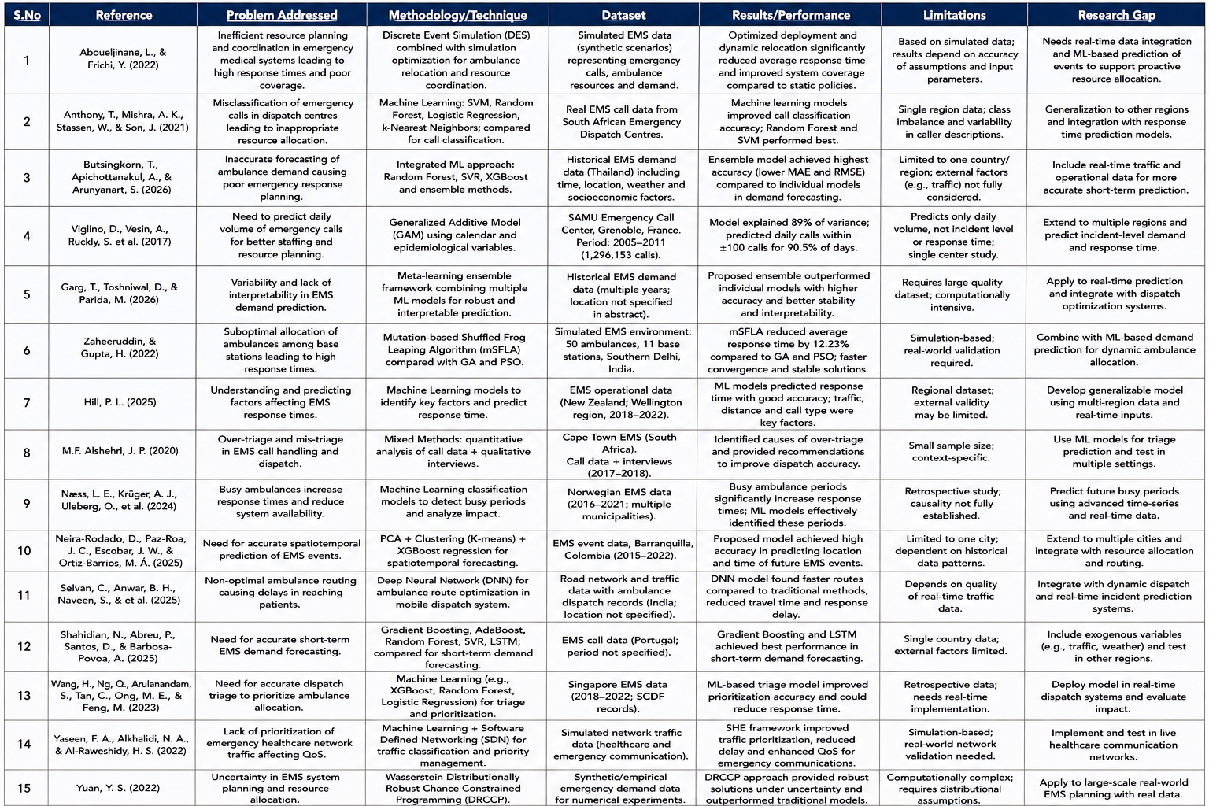
- Comparative Analysis

- References

References
Aboueljinane, L., & Frichi, Y. (2022). A simulation optimization approach to investigate resource planning and coordination mechanisms in emergency systems. Simulation Modelling Practice and Theory, 102586.
Anthony, T., Mishra, A. K., Stassen, W., & Son, J. (2021). The Feasibility of Using Machine Learning to Classify Calls to South African Emergency Dispatch Centres According to Prehospital Diagnosis, by Utilising Caller Descriptions of the Incident. Healthcare, 1107.
Butsingkorn, T., Apichottanakul, A., & Arunyanart, S. (2026). An integrated machine learning method for enhancing emergency response planning. Decision Analytics Journal, 100714.
Damien Viglino, A. V. (2017). Daily volume of cases in emergency call centers: construction and validation of a predictive model. Scand J Trauma Resusc Emerg Med 25, 86.
Garg, T., Toshniwal, D., & Parida, M. (2026). A meta-learning ensemble framework for robust and interpretable prediction of emergency medical services demand. Scientific Reports, 2132.
Gupta, Z. a. (2022). Optimally Allocating Ambulances in Delhi using Mutation based Shuffled Frog Leaping Algorithm. International Journal of Advanced Computer Science and Applications (IJACSA), 13.9.
Hill, P. L. (2025). Understanding EMS response times: a machine learning-based analysis. BMC Medical Informatics and Decision Making, 143.
M.F. Alshehri, J. P. (2020). A mixed methods investigation of emergency communications centre triage in the Government Emergency Medical Services System, Cape Town, South Africa. African Journal of Emergency Medicine, S12-S17.
Næss, L. E., Krüger, A. J., Uleberg, O., Haugland, H., Dale, J., Wattø, J.-O., . . . Asheim, A. (2024). Using machine learning to assess the extent of busy ambulances and its impact on ambulance response times: A retrospective observational study. PLOS ONE, e0296308.
Neira-Rodado, D., Paz-Roa, J. C., Escobar, J. W., & Ortiz-Barrios, M. Á. (2025). A novel machine learning approach for spatiotemporal prediction of EMS events: A case study from Barranquilla, Colombia. Heliyon, e41904.
Selvan, C., Anwar, B. H., Naveen, S., & al., e. (2025). Ambulance route optimization in a mobile ambulance dispatch system using deep neural network (DNN). Scientific Reports, 14232.
Shahidian, N., Abreu, P., Santos, D., & Barbosa-Povoa, A. (2025). Short-term forecasting of emergency medical services demand exploring machine learning. Computers & Industrial Engineering, 110765.
Wang, H., Ng, Q., Arulanandam, S., Tan, C., Ong, M. E., & Feng, M. (2023). Building a Machine Learning-based Ambulance Dispatch Triage Model for Emergency Medical Services. Health Data Science, Article 0008.
Yaseen, F. A., Alkhalidi, N. A., & Al-Raweshidy, H. S. (2022). SHE Networks: Security, Health, and Emergency Networks Traffic Priority Management Based on ML and SDN. IEEE Access, 92249–92258.
Yuan, Y. S. (2022). A Wasserstein distributionally robust chance constrained programming approach for emergency medical system planning problem. International Journal of Systems Science, 2136-2148.

